**Training Data Set Creation**

The training data set used for this analysis is shown below (first 5 lines):

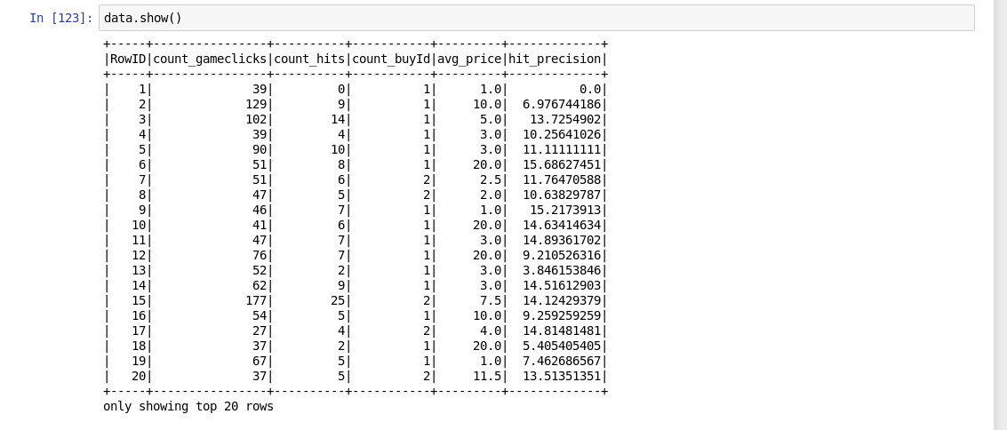

Dimensions of the final data set: **6 columns,** **1411 rows**

# of clusters created: **5 clusters (after elbow analysis)**